Virologica Sinica

Supplementary Data

Pangolin HKU4-related coronaviruses found in greater bamboo bats from southern China

Min Guo ^{a, 1}, Kai Zhao ^{b, 1}, Xingwen Peng ª, Xiangyang He ª, Jin Deng ª, Bo Wang ^{c}, Xinglou Yang ^{b, d, *,} Libiao Zhang ^{a, *}

ª Guangdong Key Laboratory of Animal Conservation and Resource Utilization, Guangdong Public Laboratory of Wild Animal Conservation and Utilization, Institute of Zoology, Guangdong Academy of Sciences, Guangzhou, 510260, China.
^{b} Yunnan Key Laboratory of Biodiversity Information, Kunming Institute of Zoology, Chinese Academy of Sciences, Kunming, 650023, China.
^{c} Department of Biomedical Sciences and Pathobiology, Virginia Polytechnic Institute and State University, Blacksburg, VA 24060, USA.
^{d} Hubei Jiangxia Lab, Wuhan, 430071, China.

¹ Min Guo and Kai Zhao contributed equally to this work.

*Corresponding authors:
E-mail address: yangxinglou@mail.kiz.ac.cn (X. Yang); zhanglb@giz.gd.cn (L. Zhang).
ORCID: 0000-0002-5317-8983 (X. Yang); 0000-0002-6919-7695 (L. Zhang).

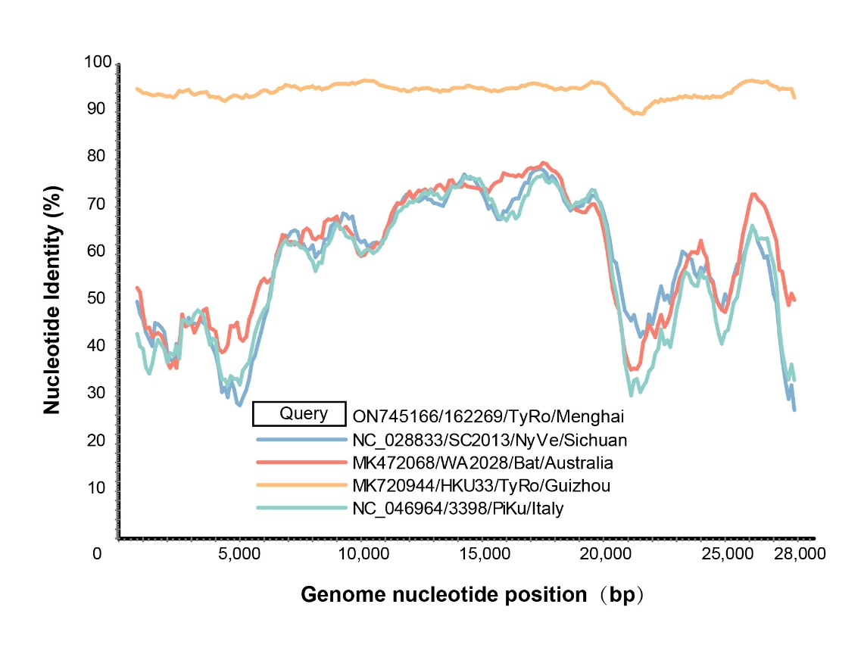
Fig. S1. Similarity plot and recombinant analysis of HKU33r-CoV TyRo-CoV-162269.

Fig. S2. Phylogenetic tree of single viral gene.

