Virologica Sinica

Supplementary Data

Taurolidine improved protection against highly pathogenetic avian influenza H5N1 virus lethal-infection in mouse model by regulating the NF-κB signaling pathway

Chaoxiang Lv ^{a, b, 1}, Yuanguo Li ^{b, c, 1}, Tiecheng Wang ^{b, 1}, Qiqi Zhang ª, Jing Qi ^{a, b}, Mingwei Sima ^{b, d},
Entao Li ^{b}, Tian Qin ^{a, b}, Zhuangzhuang Shi ^{b, e}, Fangxu Li ^{b, f}, Xuefeng Wang ^{b}, Weiyang Sun ^{b}, Na Feng ^{b}, Songtao Yang ^{b}, Xianzhu Xia ^{b}, Ningyi Jin ^{a, b, d, e, *}, Yifa Zhou ^{a, *}, Yuwei Gao ^{b, d, e, f, *}

ª College of life sciences, Northeast Normal University, Changchun, Jilin 130021, China.
^{b} Changchun Veterinary Research Institute, Chinese Academy of Agricultural Sciences. Changchun 130122, China.
^{c} College of Animal Medicine, Jilin University, Changchun 130000, China.
^{d} College of Basic Medicine, Changchun University of Chinese Medicine, Changchun 130117, China.
^{e} College of Animal Science and Technology, Jilin Agricultural University, Changchun 130033, China.
^{f} College of life sciences, Shandong Normal University, Jinan 250014, China.

¹ Chaoxiang Lv, Yuanguo Li, Tiecheng Wang contributed equally to this work.

*Corresponding Authors:
E-mail: gaoyuwei@gmail.com (Y. Gao); zhouyf383@nenu.edu.cn (Y. Zhou); ningyik@126.com (N. Jin)
ORCID: 0000-0002-8278-2418 (Y. Gao); 0000-0002-1917-2000 (Y. Zhou); 0000-0002-1744-7402 (N. Jin)

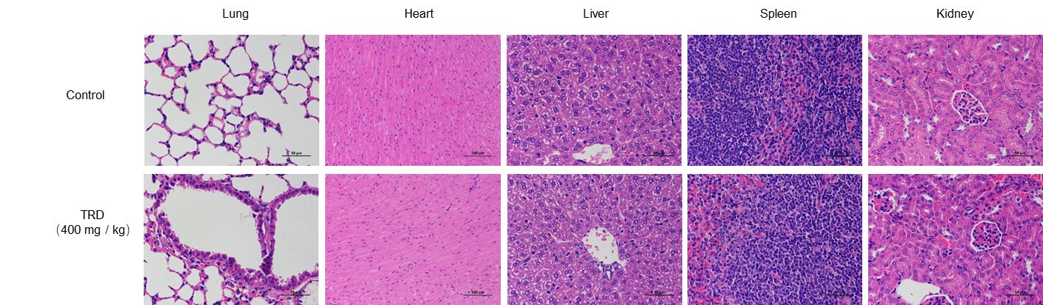
Figure S1. Effect of TRD treatment on the tissues. The effect of TRD on the mouse tissues, including heart, liver, spleen, lung and kidney.

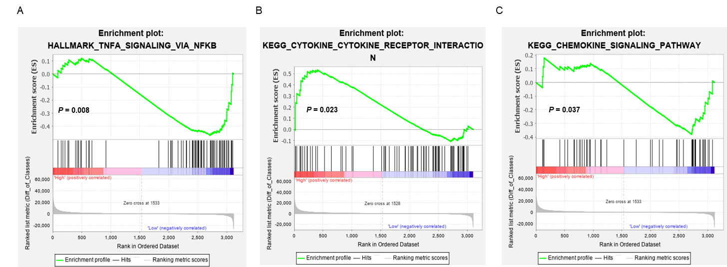
Figure S2. The effect of TRD treatment on cell signaling pathways. A GSEA analyzed global gene chip data from the lung tissues of different groups of mice after treatment TRD, and the TNF-α-NF-κB signaling pathway was significantly enriched. B The cytokine-cytokine receptor interaction signaling pathway was significantly enriched after treatment. C The chemokine signaling receptor interaction pathway was significantly enriched after treatment.

Table S1 Primer sequences for PCR
Gene Name | Primer Sequence (5′ to 3′)
M | F: 5′-CACACACGTCTCCGGGAGCAAAAGCAGGTAG-3′
 | R: 5′-CACACACGTCTCCTATTAGTAGAAACAAGGTAGTTTTT-3′
β-actin | F: 5′-TGGAATCCCTGTGGGACCATGAAAC-3′
 | R: 5′-ATCATACTTGGCAGGTTTCTCCAGG-3′
IFN-α | F: 5′-GCACCCTGCCTCAGACTCAC-3′  R: 5′-TGCCTGGTCATCTCATGGAAG-3′
IFN-γ | F: 5′-AGCCAAATCGTCTCCTTCTACTTC-3′  R: 5′-TGCACCTTGTTGCTGCTGTT-3′
TNF-α | F: 5′-AGCCCTGGTATGAACCCATC-3′  R: 5′-GGAATCGGCAAAGTCAAGGT-3′
IL-1β | F:5′-TCATCGTGGCAGTGGAAAAG-3′  R: 5′-GGGAAGCAAGGGTCTCAGGT-3′
CCL2 | F: 5′-ACACAGAAGTGGGTGCAGGA-3′  R: 5′-GTTCTTGGGGTCTTGGGTTG-3′
CCL3 | F: 5′-GCTCAACATCATGAAGGTCTCC-3′  R: 5′-TGCCGGTTTCTCTTAGTCAGG-3′
CCL5 | F: 5′-CTCCTTGCTGCTTTGCCTAC-3′  R: 5′-ACACACCTGGCGGTTCTTTC-3′
CXCL-2 | F: 5′-CTCAAGAACATCCAAAGTGTG-3′  R: 5′-ATTCTTGAGTGTGGCTATGAC-3′
CXCL-3 | F: 5′-AACCGAAGTCATAGCCACAC-3′  R: 5′-TGCTCCCCTTGTTCAGTATC-3′
IRF3 | F: 5′-GAAAGCCAGGTTATCCCAGG-3′  R: 5′-AGATTGGCTT GGGTTCGATC-3′
IRF7 | F: 5′-GCTGGACGTGACCATCATGTA-3′  R: 5′-GGGCCGTATAGGAACGTGC-3′

