Virologica Sinica
Supplementary Material

Mast cell degranulation-triggered by SARS-CoV-2 induces tracheal-bronchial epithelial inflammation and injury

Jian-Bo Cao ^{a, b, 1}, Shu-Tong Zhu ^{a, 1}, Xiao-Shan Huang ^{a, 1}, Xing-Yuan Wang ª, Meng-Li Wu ª, Xin-Li ª,
Feng-Liang Liu ^{c}, Ling Chen ª, Yong-Tang Zheng ^{c,*}, Jian-Hua Wang ^{a, d, *}

ª Guangzhou Institutes of Biomedicine and Health, Chinese Academy of Sciences, Guangzhou 510530, China;
^{b} School of Life Sciences and Medicine, University of Science and Technology of China, Hefei 230026, China.
^{c} Key Laboratory of Bioactive Peptides of Yunnan Province, Key Laboratory of Animal Models and Human Disease Mechanisms of the Chinese Academy of Sciences, KIZ-CUHK Joint Laboratory of Bioresources and Molecular Research in Common Diseases, Center for Biosafety Mega-Science, Kunming Institute of Zoology, Chinese Academy of Sciences, Kunming 650223, China
^{d} University of Chinese Academy of Sciences, Beijing 100039, China.

¹Jian-Bo Cao, Shu-Tong Zhu, and Xiao-Shan Huang contribute equally.

*Correspondence authors
Email: wang_jianhua@gibh.ac.cn (J.-H, Wang); zhengyt@mail.kiz.ac.cn (Y.-T Zheng)
ORCID: 0000-0002-6435-9907 (J.-H, Wang), 0000-0001-5469-0324 (Y.-T Zheng)

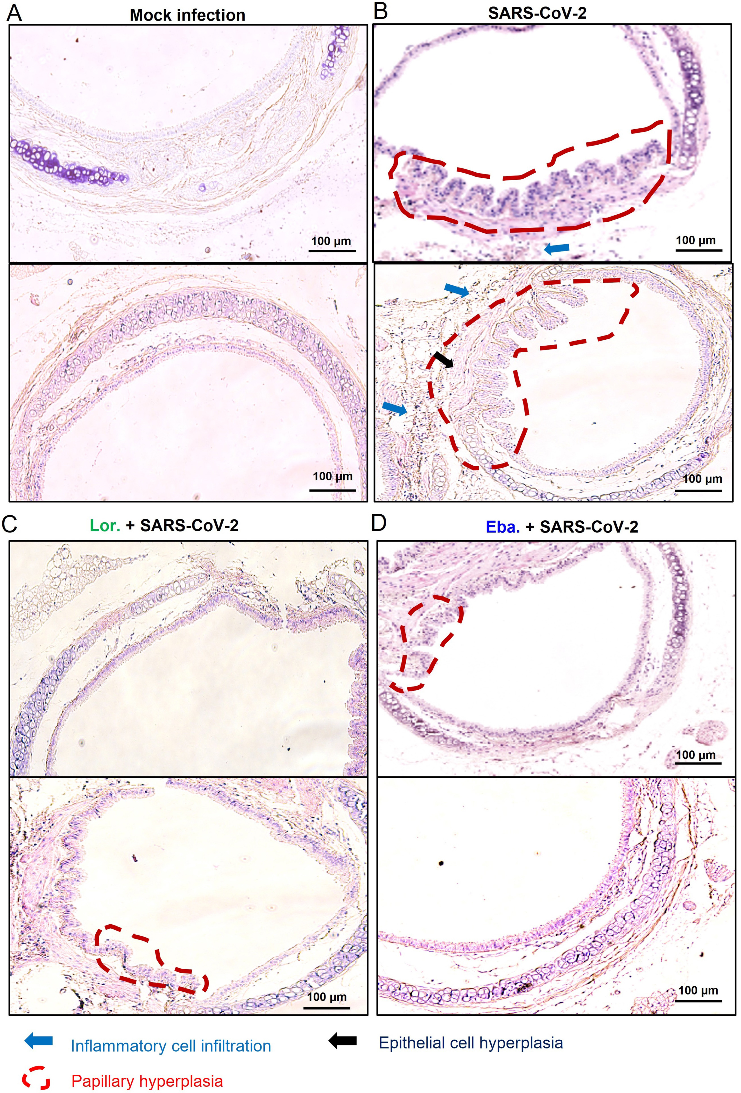
Supplementary Fig S1. The prior-treatment with loratadine and ebastine reduces SARS-CoV-2-mediated tracheal lesions in mice. A, B C57BL/6N-ACE2^{em2(hACE2-WPRE, pgk-puro)/CCLA} mice were infected intranasally with SARS-CoV-2 (strain 107) at a dose of 5×10⁶ TCID₅₀ (B). Mock infection was established with the same amount of PBS. The loratadine (Lor., 10 mg/kg) (C) or ebastine (Eba., 5 mg/kg) (D) was administered one day before infection, and the treatments were continued daily throughout the infection. Mice were euthanized at day 5 post-infection and trachea were harvested for pathological analysis with Hematoxylin and Eosin staining to observe the trachea injury. Scale bar: 100 μm.

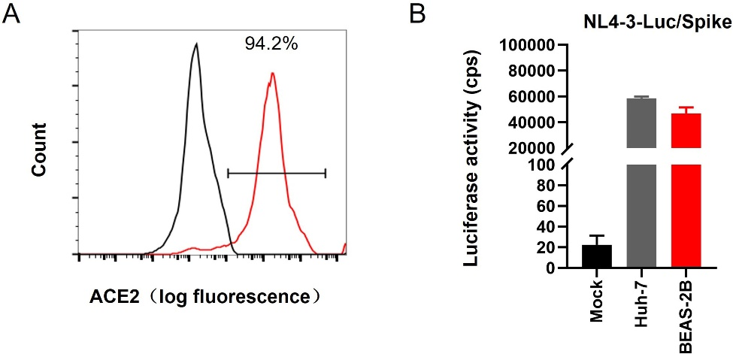
Supplementary Fig S2. The infection of BEAS-2B cells by pseudotyped virus. A ACE2 expression in BEAS-2B cells detected by flow cytometry with immunostaining. B BEAS-2B cell or Huh-7 cells (1×10⁵) were infected with SARS-CoV-2 spike-pseudotyped lentivirus (NL4-3-Luc/spike) (5 ng p24^{gag}) for 48 h, and viral infection was determined by measuring the luciferase activity. One representative data from 3 independent repeats are shown. Data are presented as mean ± SD.

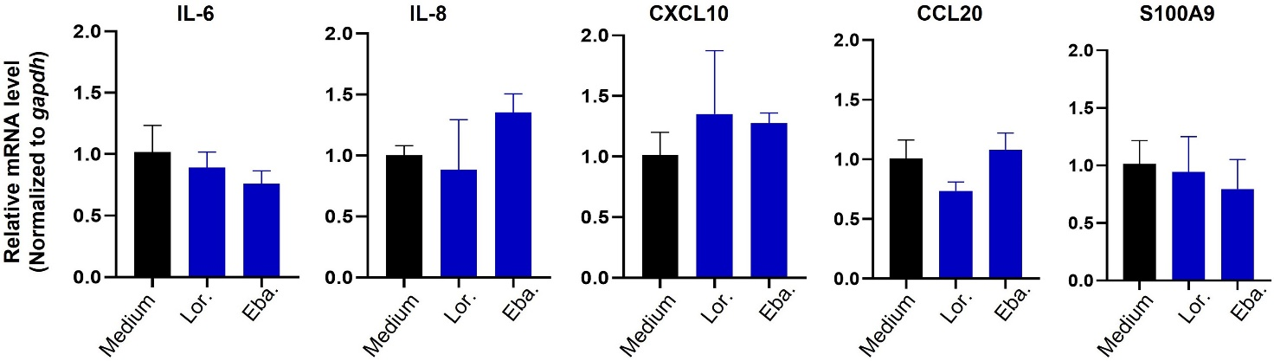

Supplementary Fig S3. The effect of treatment with loratadine and ebastine on cytokine expression in BEAS-2B cells. BEAS-2B cells (2×10⁵) were stimulated with loratadine (Lor., 5 μg/mL) or ebastine (Eba., 3 μg/mL) for 12 h, The mRNA levels of cytokines were detected with real time qRT-PCR, and normalized to gapdh mRNA. One representative data from 3 independent repeats are shown, data are mean± standard deviation (SD).

Supplementary Table S1. The primers for (RT-) PCR. The primers used for (RT)-PCR were listed.
Human IL-6 | Forward | 5′-CAG ACA GCC ACT CAC CTC TTC AG-3′
 | Reverse | 5′-CAG CCA TCT TTG GAA GGT TCA G-3′
Human IL-8 | Forward: | 5′-CTG ATT TCT GCA GCT CTG TGT GA-3′
 | Reverse | 5′-GGT CCA GAC AGA GCT CTC TTC CA-3′
Human CCL20 | Forward: | 5′-GCT GCT TTG ATG TCA GTG CT-3′
 | Reverse | 5′-TGT CAC AGC CTT CAT TGG C-3′
Human CXCL10 | Forward | 5′-GTGGCATTCAAGGAGTACCTC-3′
 | Reverse | 5′-TGATGGCCTTCGATTCTGGATT-3′
Human S1009A | Forward | 5′-GCAGCTGGAACGCAACATAG-3′
 | Reverse | 5′-GTCACCCTCGTGCATCTTCT-3′
Human GAPDH | Forward | 5′-ATC CCA TCA CCA TCT TCC AGG-3′
 | Reverse | 5′-CCT TCT CCA TGG TGG TGA AGA C-3′

