Virologica Sinica
Supplemental materials

The infection kinetics and transmission potential of two Guaico Culex viruses in Culex quinquefasciatus mosquitoes

Ru-Yi Chen^{a, b, 1}, Teng Zhao ^{b, 1}, Jing-Jing Guo ^{b, 1}, Feng Zhu ^{b, c, 1}, Na-Na Zhang ^{b}, Xiao-Feng Li ^{b}, Hai-Tao Liu ^{b}, Fei Wang ^{a,} *, Yong-Qiang Deng ^{b,} *, Cheng-Feng Qin ^{b,} *

ª College of Bioscience and Bioengineering, Jiangxi Agricultural University, Nanchang 330045, China.
^{b} State Key Laboratory of Pathogen and Biosecurity, Beijing Institute of Microbiology and Epidemiology, AMMS, Beijing 100071, China.
^{c} School of Life Sciences, Southwest Forestry University, Kunming 650224, China

¹ Ru-Yi Chen, Teng Zhao, Jing-Jing Guo, and Feng Zhu contributed equally to this work and shared the first authorship.

*Corresponding authors:
E-mail address: Fei Wang (wangfei179@163.com); Yong-Qiang Deng (dengyq1977@126.com); Cheng-Feng Qin (qincf@bmi.ac.cn)
ORCID: 0000-0002-8035-4786 (F. Wang); 0000-0002-2306-1039 (Y.Q. Deng); 0000-0002-0632-2807 (C.F. Qin)

Tables
Table S1. Primers and probes used in RT‒qPCR assay.
Target | Primer/Probe | Sequence (5′ –3′)
Segment1 | S1-Fwd | ATGGAATGGGTGCGCTTTAC
 | S1-Rev | TGGTTCTGATTGAGCGGGAT
 | S1-Probe | FAM- CGCTCCGCTCACTCCAGAACATCA-BHQ1
Segment2 | S2-Fwd | CCACCCTGACTTTCTAACGGA
 | S2-Rev | ACGGGTATTTCCGCATACAGG
 | S2-Probe | FAM-ACGGAACCACGCCAAGCTTCATCCACC-BHQ1
Segment3 | S3-Fwd | TCCCTGTCCTCCTAACCCTATT
 | S3-Rev | ATTGACTGTTGAGGATCGGAGT
 | S3-Probe | FAM-AATGTGCAGATCTGGAACTCGCTGATG-BHQ1
Segment4 | S4-Fwd | GGGCGACGAAATGAAGGC
 | S4-Rev | GTAGGTGCGGTTGTTGAAGC
 | S4-Probe | FAM-TAGACGGAGACAGCGAGAGCGG-BHQ1
Segment5 | S5-Fwd | GAAAGCCATCCCTCATGCTG
 | S5-Rev | ACCTTACCACGAAGCAGACA
 | S5-Probe | FAM-CGGTCCCGACAAAGCTACCTGGT-BHQ1
RPL8 | RPL8-Fwd | AGTTCAAGCTCCGCAAGCA
 | RPL8-Rev | CACGAACTGGCCGGTGTAC

Supplementary figure
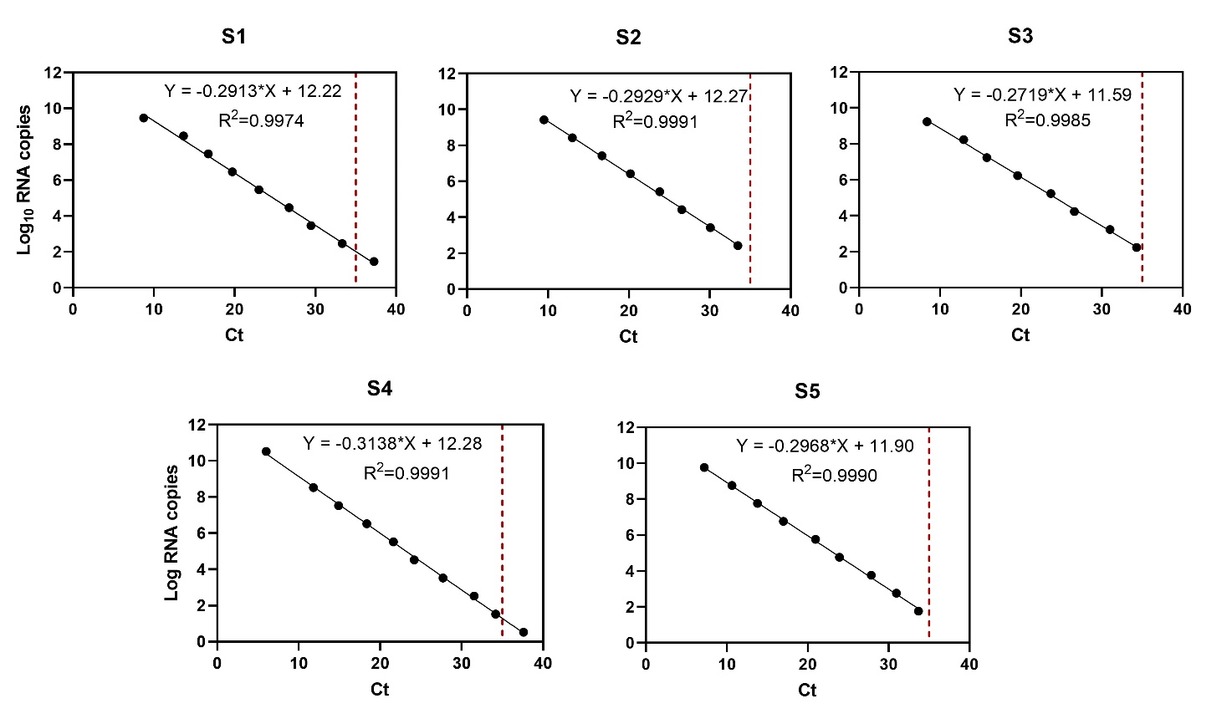
Supplementary Figure S1. Log-linear regressions fit to the standard curves for the GCXV-LO35 Segment 1–5 detection assays. Determination of viral RNA copies of target segment 1 (S1) to segment 5 (S5). The number of CP cycles versus the number of log viral RNA copies was plotted to calculate the slope. The corresponding number of virus-specific RNA copies was calculated according to the following equation: The detection limit is indicated by red dashed lines (Ct = 35). The linear equation and R² values for the linear fit to each set of data are shown.

