Virologica Sinica
Supplemental materials

Non-proteolytic ubiquitination of HBx controls HBV replication

Xiangpeng Sheng ^{a, b, c, 1,} *, Yi Yang ^{d, 1}, Min Zhu ^{e, 1}, Linlin Zhou ^{f, 1}, Fang Zhu ^{g, 1}, Yuanfei Zhu ^{h, 1},
Siying Dong ^{b}, Hui Kong ª, Honghua Wang ^{c}, Ji Jiang ^{e}, Mingyue Wan ^{i}, Mingyang Feng ^{i}, Qiang Deng ^{h},
Yumin Xu ^{i,} *, Qing You ^{j,} *, Ronggui Hu ^{b, c,} *

ª State Key Laboratory for Animal Disease Control and Prevention, Harbin Veterinary Research Institute, Chinese Academy of Agricultural Sciences, Harbin 150069, China.
^{b}State Key Laboratory of Molecular Biology, Shanghai Institute of Biochemistry and Cell Biology, Center for Excellence in Molecular Cell Science, Chinese Academy of Sciences, Shanghai 200031, China.
^{c} Key Laboratory of Systems Health Science of Zhejiang Province, School of Life Science, Hangzhou Institute for Advanced Study, University of Chinese Academy of Sciences, Hangzhou, 310024, China.
^{d}Department of Thoracic Surgery, Ruijin Hospital, Shanghai Jiaotong University School of Medicine, Shanghai 200025, China
^{e}Shanghai Key Laboratory of Plant Molecular Sciences, College of Life Sciences, Shanghai Normal University, Shanghai 200234, China.
^{f}Department of Pathogenic Biology, West China School of Basic Medical Sciences & Forensic Medicine, Sichuan University, Chengdu 610041 China
^{g}School of Medicine, Guizhou University, Guiyang 550025, China
^{h}Key Laboratory of Medical Molecular Virology (MOE & MOH), School of Basic Medical Sciences, Fudan University, Shanghai 200032, China
^{i}Department of Hospital Infection Management, Department of Infectious Diseases, Ruijin Hospital, Shanghai Jiao Tong University School of Medicine, Shanghai 200025, China.
^{j}School of Biomedical Engineering, Shanghai Jiao Tong University, Shanghai 200240, China.

¹Xiangpeng Sheng, Yi Yang, Min Zhu, Linlin Zhou, Fang Zhu, and Yuanfei Zhu contributed equally to this article.

*Correspondence:
Email addresses: coryhu@sibcb.ac.cn (R. Hu); youqing@sjtu.edu.cn (Q.You); shengxiangpeng@ucas.ac.cn (X. Sheng); xym121@163.com (Y. Xu)
ORCID: 0000-0002-3939-6087 (R. Hu); 0009-0003-7286-4086 (X. Sheng)

Materials and Methods
2.1. Mice
Male 4~5-week-old C57BL/6 mice were hydrodynamically co-injected with several plasmids (3 μg prcccDNA, 3 μg pCMV-Cre, and 3 μg pcDNA3.0-empty or pcDNA3.0-TRIM21-HA) diluted in PBS to reach a volume equivalent to 8% of the mouse body weight. The hydrodynamic injection was finished within 5–8 s through tail veins. Mouse serum HBsAg was detected on day 3, 7, 10, 14. All animal experiments were approved by the Animal Ethics Committee of Institute Pasteur of Shanghai (No. A2012008-2).
2.2. Patients
Liver biopsies were acquired from Huashan Hospital of Fudan University, and the clinical/virologic parameters of patients were summarized in Supplementary Figure S1A. All patients in the study had written the informed consent. The study was approved by the Research Ethics Committee of Huashan hospital of Fudan University.
2.3. Cell lines and transfection
The human hepatoma cell line HepG2 and human embryonic kidney cell line HEK293T were cultured in Dulbecco’s modified Eagle’s medium (DMEM) (Hyclone) supplemented with 10% fetal bovine serum (FBS), 2.0 mmol/L L-glutamine, 100 U/mL penicillin, and 100 mg/mL streptomycin. Cells were maintained in 5.0% CO₂ at 37 °C. All cell lines were routinely tested for mycoplasma contamination.
HepG2 cells were transfected with the indicated plasmids using lipofectamine 2000 (Life Technologies) according to the manufacturer's instructions while transfection of HEK293T cells was conducted using polyethylenimine (Sigma).
2.4. Plasmids, antibodies and reagents
The detailed information of antibodies and plasmids is listed in Supplementary Table S5 and S6. Briefly, for plasmid construction, restriction enzyme digestion and ligation reactions (NEB) were performed using traditional cloning methods. All the point mutations were generated using the QuickChange Site-Directed Mutagenesis Kit (Stratagene) according to the manufacturer's protocol. All constructs were verified by DNA sequencing.
2.5. Expression and purification of recombinant proteins
E. coli BL21 (DE3) harboring the corresponding recombinant plasmids were grown in LB medium supplemented with appropriate antibiotics and when OD600 reached 0.6–0.8, the protein expression was induced for 16–20 h at 16 °C by 0.25 mmol/L IPTG (isopropyl β-D-1-thiogalactopyranoside; Sigma). For His₆-tagged proteins, the purification was conducted with affinity chromatography using Ni-NTA beads (Qiagen); for GST fusion proteins, purification was performed by affinity chromatography using Glutathione Sepharose Fast Flow beads (GE Healthcare). After dialyzed overnight at 4 °C, protein concentrations were determined using Bradford colorimetric assays.
2.6. GST pull-down assay
The GST pull-down assay was performed according to our previous study (Sheng et al., 2020). Purified HBx-His, GST-TRIM21 (WT and truncations) or GST proteins, and Glutathione Sepharose 4B beads (GE Healthcare) were incubated in 500 μL pull-down buffer (20 mmol/L Tris-Cl, 100 mmol/L NaCl, 5 mmol/L MgCl₂, 1 mmol/L EDTA, 1 mmol/L DTT, 0.5% (v/v) NP-40, and 10 µg/mL BSA, pH 7.5) for 6 h at 4 °C. The beads were washed four times with the pull-down buffer (10 min for each wash with rotation). The recovered beads were boiled with 2× SDS loading buffer and subjected to immunoblotting analysis with indicated antibodies.
2.7. Co-immunoprecipitation (Co-IP) and immunoblotting (IB)
For Co-IP assay, HEK293T cells expressing the proteins of interest were lysed in Co-IP buffer (50 mmol/L Tris-HCl at pH 7.4, 150 mmol/L NaCl, 1% Triton X-100) plus 1% protease inhibitor cocktail (Selleck). After centrifugation to remove the cell debris, the supernatant was incubated with Anti-Flag or Anti-HA affinity gel overnight at 4 °C. After washing, the immunoprecipitants were boiled at 100 °C for 10 min in 2× SDS loading buffer.
The immunoprecipitants and other cell lysates were then subjected to SDS-PAGE gel and transferred to PVDF membrane (Bio-Rad, Hercules, CA, USA). The membranes were blocked for 1 hour in TBST containing 5% non-fat milk at 25 °C and then incubated with primary antibodies overnight at 4 °C. After washing with TBST buffer, the PVDF membranes were then incubated in HRP (Horseradish peroxidase)-conjugated secondary antibodies for 1 hour at 25 °C. After another washing, the signals were finally visualized with Super Signal West Pico kit (Thermo Scientific).
2.8. In vitro ubiquitylation assay
As previously described with some modifications (Sheng et al., 2017), in vitro ubiquitylation assays were carried out in a 30 μL reaction system containing E1 (100 ng), His₆-tagged UBC4 (200 ng), GST-TRIM21 (500 ng), Flag-HBx (500 ng) and ubiquitin (1 μg) in ubiquitylation buffer (50 mmol/L Tris ± HCl, pH 7.5, 5.0 mmol/L MgCl₂, 2.0 mmol/L ATP, 1 mmol/L DTT) at 37 °C for 60 min. After the reaction, the resulting mixtures were boiled and the ubiquitylation levels of HBx were detected with anti-Flag antibody.
2.9. In vivo ubiquitylation assay
Cells transfected with indicated plasmids were harvested, lysed in buffer A (50 mmol/L Tris-Cl, 150 mmol/L NaCl, 1% NP-40, 1% sodium deoxycholate, 1% SDS, PH 7.6), boiled at 95 °C for 10 min for denaturing, then diluted 10 times with buffer B (50 mmol/L Tris-Cl, 150 mmol/L NaCl, pH 7.6) supplemented with 1% protease inhibitor cocktail (Selleck) and sonicated, followed by immunoprecipitation with Anti-Flag affinity gel at 4 °C overnight, washed three times with RIPA buffer (50 mmol/L Tris-Cl, 150 mmol/L NaCl, 1% NP-40, 0.5% sodium deoxycholate, and 0.1% SDS, pH 7.6). The immunoprecipitants were boiled in 2× SDS loading buffer and subjected to SDS-PAGE followed by immunoblotting analysis with indicated antibodies.
2.10. Ubiquitylation assay in reconstituted E. coli system
The Ubiquitylation assay in reconstituted E. coli system was performed as described before (Li et al., 2020). pYESS-HA-Ub-UbcH5a-UBA1 or pYESS-HA-Ub-UbcH5a-UBA1-TRIM21 and pET22b-HBx were co-transformed into E. coli BL21 competent cells. The E. coli cell was cultured in LB medium and induced by 0.25 mmol/L IPTG at 16 °C for 12 h when OD₆₀₀ reached 0.6–0.8. Next day, the cells were harvested and re-suspended in 8 mol/L Urea lysis buffer (50 mmol/L Tris-Cl, 50 mmol/L Na₂HPO₄, 0.5% NP-40, 300 mmol/L NaCl, 8 mol/L Urea, and 20 mmol/L imidazole, pH 8.0) for sonication. The debris were pelleted by centrifugation and discarded, while the supernatants were purified with Ni-NTA agarose beads for 4 h at 25 °C, washed 3 times with 8 mol/L Urea lysis buffer and eluted with RIPA buffer (50 mmol/L Tris-Cl, 150 mmol/L NaCl, 5 mmol/L EDTA, 1% NP40, 0.1% SDS, pH 7.4) that was supplemented with 1 mol/L imidazole. Then diluted 10 times with RIPA buffer and the second immunoprecipitation was performed with anti-HA affinity gel and washed three times with RIPA buffer before eluting with 8 mol/L Urea buffer (100 mmol/L Tris-Cl, 8 mol/L Urea, pH 8.0). The ubiquitylation level was examined by immunoblotting assay.
2.11. Immunofluorescence
For immunofluorescence assay, cells were fixed with 4% paraformaldehyde for 10–20 min at 25 °C, permeabilized with 0.1% Triton X-100 in PBS for 10 min, blocked with 3.0 % BSA in PBST for 60 min, and then incubation with TRIM21 antibody at 4 °C overnight followed by dye-conjugated secondary antibodies. All the cell nuclei were counterstained with DAPI before imaging. Images were recorded with microscope Olympus SpinSR.
2.12. Enzyme-linked immunosorbent assay (ELISA)
About 72 h after transfection, the supernatants of HBV-replicating cells were collected and the levels of HBsAg and HBeAg were measured using the ELISA kits (Shanghai Kehua Bio-engineering Co., Ltd).
2.13. Luciferase reporter assays
HEK293T cells were seeded at 0.5 × 10⁵ cells/well in 24-well plates. After overnight culture, cells were transiently transfected with a reporter plasmid carrying the HBV enhancer I element (Treinin and Laub, 1987; Doitsh and Shaul, 2004), PRL-TK, and HBx-Flag or HBx-2A-Flag. After 48h transfection, the cells were harvested and lysed with 5× passive buffer and subjected to Dual-Luciferase Reporter assay according to manufacturer’s instruction (Promega).
2.14. Chromatin immunoprecipitation (ChIP)
HepG2 cells were crosslinked with 1.0% formaldehyde (Sigma) for 10 min at 25 °C, quenched with 125 mmol/L glycine, then washed twice with ice-cold PBS, followed by resuspended with lysis buffer (50 mmol/L Tris-Cl PH 8.0, 10 mmol/L EDTA, 1% SDS, and protease inhibitor). Cellular lysates were sonicated with Bioruptor (UCD-300) for 35 cycles of 30s on and 30s off at high power setting, diluted 10 times with ChIP dilution buffer (20 mmol/L Tris-Cl PH 8.0, 0.01% SDS, 1.1% Triton X-100, 1.1 mmol/L EDTA,167 mmol/L NaCl) and immunoprecipitated with 5 µg of control IgG or anti-AcH3 antibody at 4 °C overnight. Immunoprecipitants were further incubated with Protein G beads at 4 °C for 2 h and then washed with Low Salt wash Buffer (20 mmol/L Tris-Cl PH 8.0 ,150 mmol/L NaCl, 0.1% SDS, 1% Triton X-100, 2 mmol/L EDTA), High Salt wash Buffer (20 mmol/L Tris-Cl PH 8.0, 500 mmol/L NaCl, 1% NP-40, 0.1% SDS, 2 mmol/L EDTA), LiCl wash Buffer (20 mmol/L Tris-Cl PH 8.0, 500 mmol/L LiCl, 1% NP-40, 1 mmol/L EDTA, 1% deoxycholate), and TE buffer (100 mmol/L Tris-Cl PH 8.0, 1 mmol/L EDTA). DNA-protein immune complex was eluted with fresh elution buffer (1% SDS and 0.1 mol/L sodium bicarbonate) and the elution were adjusted to 300 mmol/L NaCl and incubated at 65 °C for 4 h, followed by incubation at 55 °C for 1 h with 50 μg proteinase K. DNA was purified using phenol-chloroform approach and subjected to quantitative PCR.
2.15. RNA-Seq Data Analysis
We collected Illumina paired-end reads and gene expression matrix of tumor and adjacent normal tissues from 50 HCC patients (GEO database http://www.ncbi.nlm.nih.gov/geo/query/acc.cgi?acc=GSE65484) (Dong et al., 2015). By using BowTie 2 (Langmead and Salzberg, 2012), the filtered reads were mapped to HBV reference sequences (RefSeq: GCF_000861825.2). Subsequently, we used GATK DepthOfCoverage (McKenna et al., 2010) to estimate the nucleotide coverage per position. To identify chimeric transcripts of HBV on the human genome, a de novo transcriptome assembly was crafted using the Trinity tool (Grabherr et al., 2011) to pinpoint integration sites. We employed Blast tools to compare contigs with the corresponding HBV reference sequence. Only contigs with remarkable alignment scores, boasting e-values < 10⁻⁶ and identity scores ≥ 98%, were selected. Subsequently, these selected contigs underwent alignment against the Human Genome Build 37 using Blast online (https://blast.ncbi.nlm.nih.gov/Blast.cgi) and served as the reference for precisely mapping RNA-Seq reads with the BowTie 2. Estimating the number of reads overlapping at least six nucleotides in both directions at the borders of each HBV/human junction allowed us to accurately gauge the read coverage of each chimeric sequence. Our results align seamlessly with the findings reported by Dong et al. (2015).
To quantitatively evaluate the relationship between TRIM21 expression levels and the degree of HBV infection, we conducted a correlation analysis by testing the association between the HBV integrated quantity and PKM values of TRIM21. This analysis was performed using the 'lm' (linear regression) function in the R programming language, and the 'ggpubr' package was utilized for data visualization.
2.16. Construction of HBx-expressing HepG2 stable cell lines
The transfer plasmid (pCDH empty vector, pCDH-HBx-Flag, or pCDH-HBx-2A-Flag), packaging plasmid psPAX2 (Addgene), and envelope plasmid pMD2.G (Addgene) were co-transfected with a ratio of 4.3:1.7:6.0 into HEK293T cells for 72 hours to generate lentivirus. Lentivirus supernatant was filtered by 0.45 μm filters and used to lentivirus transduction in HepG2 cells. After 48 hours, HepG2 cells were digested by trypsin and then selected in the complete medium supplemented with 4 μg/mL puromycin for several passages.
2.17. Knockdown of TRIM21 in HepG2 stable cell lines
Three guide sequences targeting human TRIM21 gene were obtained by online CRISPOR (http://crispor.tefor.net/): (1) 5′- CATGTTGGCTAGCTGTCGAT -3′; (2) 5′- AGCACGCTTGACAATGATGT -3′; (3) 5′- TCATCTCAGAGCTAGATCGA -3′.
These three target guides and one negative control guide (5'-ACGGAGGCTAAGCGTCGCAA-3') were synthesized and cloned to lentiCRISPRv2 backbone (blasticidin), based on a previous report (Sanjana et al., 2014). psPAX2, pMD2.G, and lentiCRISPRv2 plasmids encoding sgRNAs were co-transfected into HEK293FT cells for 72 h, and the virus supernatant was filtrated by 0.45 μm filters. Filtered virus supernatant was mixed with fresh medium and polybrene (8~10 μg/mL), and utilized to transduce HepG2 cells. After 48 h, cells were selected in 4 μg/ml puromycin and 10 μg/mL blasticidin for several passages.
2.18. Analysis of HBV pgRNA and total RNA
RNA extraction, reverse transcription, and qPCR analysis of HBV pgRNA and total RNA were performed according to a previous study (Wang et al., 2016).
2.19. Statistical analysis
Statistical significance of the data in this study was determined using the Student's t-test. In all experiments, only P value of < 0.05 was considered to be statistically significant.
References
Doitsh G, Shaul Y. 2004. Enhancer i predominance in hepatitis b virus gene expression. Molecular and cellular biology, 24: 1799-1808.
Dong H, Zhang L, Qian Z, Zhu X, Zhu G, Chen Y, Xie X, Ye Q, Zang J, Ren Z. 2015. Identification of hbv-mll4 integration and its molecular basis in chinese hepatocellular carcinoma. PloS one, 10: e0123175.
Grabherr MG, Haas BJ, Yassour M, Levin JZ, Thompson DA, Amit I, Adiconis X, Fan L, Raychowdhury R, Zeng Q. 2011. Trinity: Reconstructing a full-length transcriptome without a genome from rna-seq data. Nature biotechnology, 29: 644.
Langmead B, Salzberg SL. 2012. Fast gapped-read alignment with bowtie 2. Nature methods, 9: 357-359.
Li C, Han T, Guo R, Chen P, Peng C, Prag G, Hu R. 2020. An integrative synthetic biology approach to interrogating cellular ubiquitin and ufm signaling. Int. J. Mol. Sci., 21: 4231.
McKenna A, Hanna M, Banks E, Sivachenko A, Cibulskis K, Kernytsky A, Garimella K, Altshuler D, Gabriel S, Daly M. 2010. The genome analysis toolkit: A mapreduce framework for analyzing next-generation DNA sequencing data. Genome research, 20: 1297-1303.
Sanjana NE, Shalem O, Zhang F. 2014. Improved vectors and genome-wide libraries for crispr screening. Nature methods, 11: 783-784.
Sheng X, You Q, Zhu H, Li Q, Gao H, Wang H, You C, Meng Q, Nie Y, Zhang X. 2020. Enterohemorrhagic e. Coli effector nlel disrupts host nf-κb signaling by targeting multiple host proteins. J. Mol. Cell Biol, 12: 318-321.
Sheng X, You Q, Zhu H, Chang Z, Li Q, Wang H, Wang C, Wang H, Hui L, Du C, Xie X, Zeng R, Lin A, Shi D, Ruan K, Yan J, Gao GF, Shao F, Hu R. 2017. Bacterial effector nlel promotes enterohemorrhagic e. Coli-induced attaching and effacing lesions by ubiquitylating and inactivating jnk. PLoS pathogens, 13: e1006534.
Treinin M, Laub O. 1987. Identification of a promoter element located upstream from the hepatitis b virus x gene. Molecular and cellular biology, 7: 545-548.
Wang J, Shen T, Huang X, Kumar GR, Chen X, Zeng Z, Zhang R, Chen R, Li T, Zhang T. 2016. Serum hepatitis b virus rna is encapsidated pregenome rna that may be associated with persistence of viral infection and rebound. Journal of hepatology, 65: 700-710.

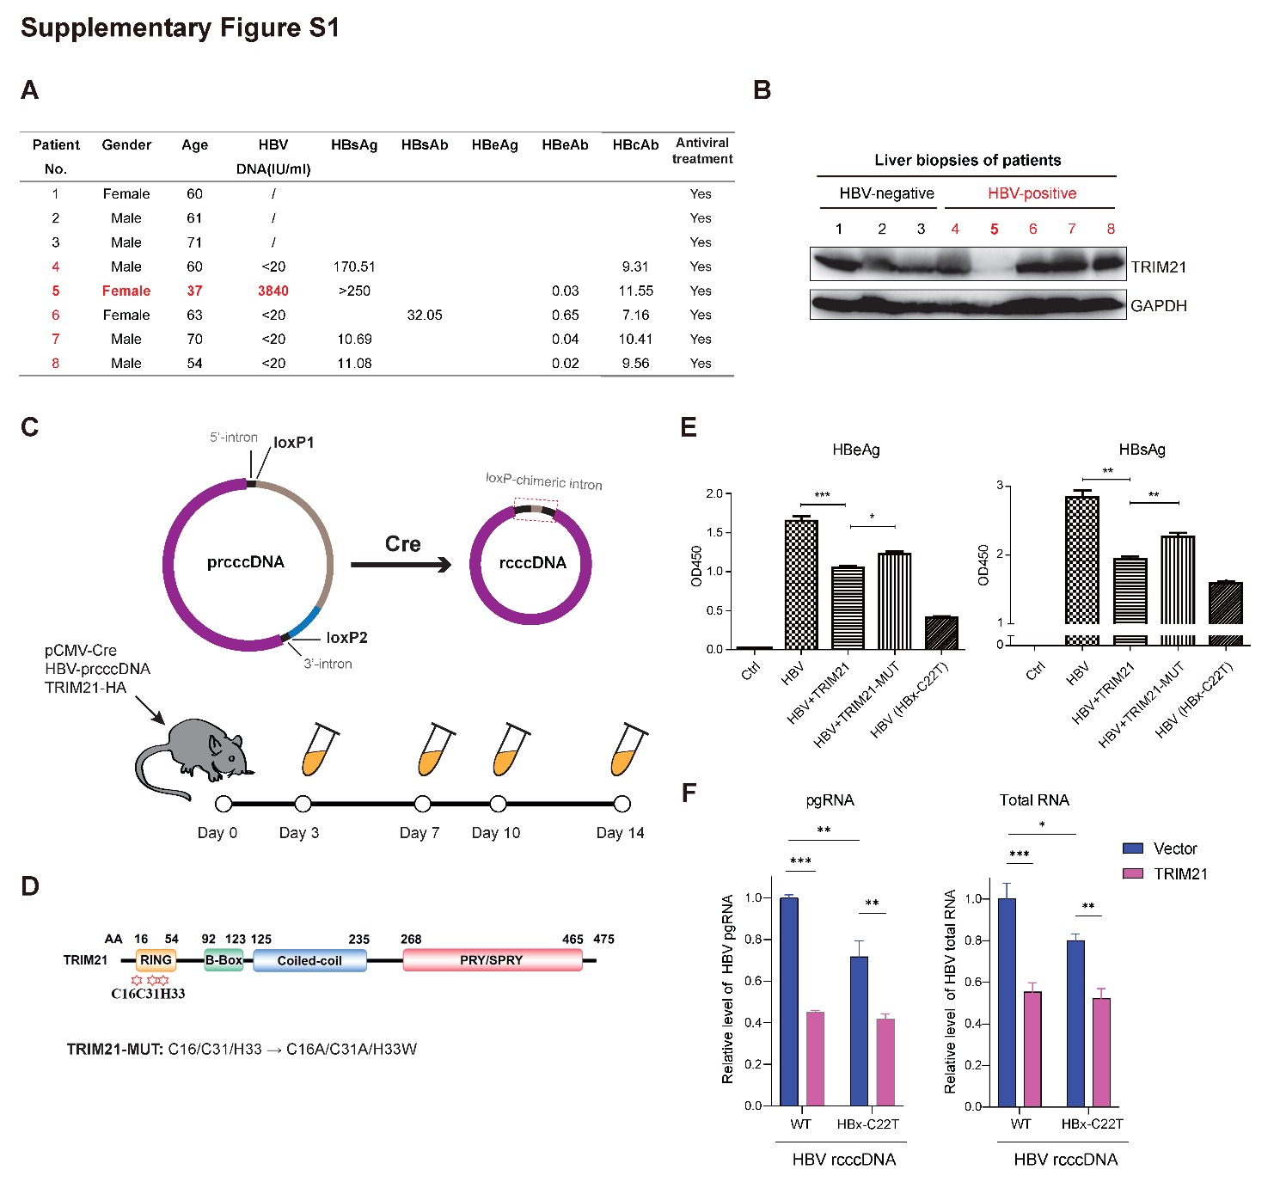
Supplementary Fig. S1. TRIM21 inhibits HBV replication in vivo. A The information of three HBV-negative patients and five chronic hepatitis B patients (CHB) (red). B The protein levels of TRIM21 in liver tissues were analyzed by immunoblotting. Liver biopsies from (A) were collected and subjected to protein extraction. C Schematic diagram of the experimental design for mouse HBV infection assay. A Cre/loxP-based recombination system that generates viable HBV recombinant covalently closed circular (rcccDNA) allows full recapitulation of HBV replication cycle. A Hydrodynamic gene injection (HDI)-based HBV infection mouse model was used. D Schematic overview of C16, C31, and H33 residues in the RING domain of TRIM21. TRIM21-MUT was constructed as shown and deficient of E3 ligase activity. E TRIM21 suppresses the expression of HBsAg and HBeAg in HepG2. Cells were transfected with HBV rcccDNA and TRIM21 or TRIM21-MUT. C22T substitution in HBx gene introduces a stop site at the N terminal of HBx, abolishing HBx expression. F TRIM21 overexpression or HBx deficiency can suppress the production of HBV pgRNA or total RNA in HepG2. HepG2 cells transfected with wild-type (WT) or HBx-deficient HBV rcccDNA and TRIM21-expressing plasmid for 72h. qPCR analysis of HBV pgRNA and total RNA was then conducted after RNA extraction and reverse transcription. Data were mean ± s.d. from three biological replicates, *P < 0.05, **P < 0.01, ***P < 0.001. (Student’s t-test)
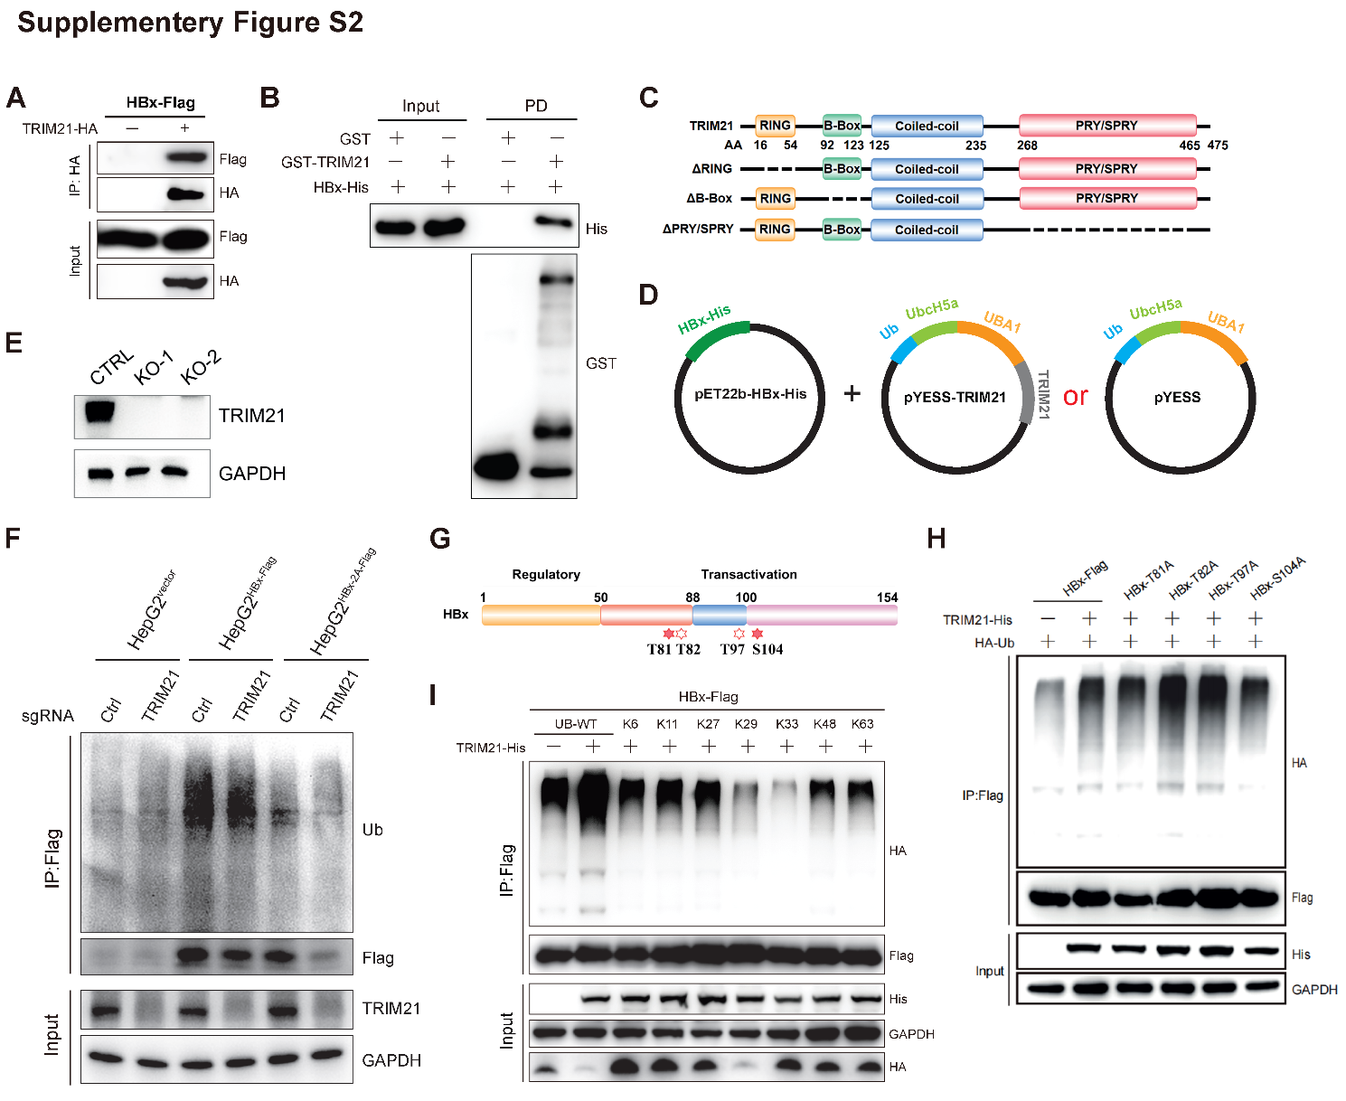
Supplementary Fig. S2. TRIM21 interacts with and ubiquitinates HBx. A Co-immunoprecipitation assay showed that TRIM21 interacts with HBx in HEK293T. B A GST pull-down assay was performed to validate the direct interaction between recombinant HBx-His and GST-TRIM21 proteins in vitro. PD: pull-down. C Schematic diagram of domain structures of WT and truncated TRIM21. D Plasmids used in E. coli-based system. pET22b-HBx-His expresses his-tagged HBx, and YESS^{UB} vector expresses HA-Ub, E1 (UBA1), E2 (UBCH5a) with or without E3 (TRIM21) in E. coli BL21. E Western blot analysis of TRIM21 protein levels in WT and TRIM21-KO HEK293T cell lines. F HBx-2A undergoes less ubiquitination in HBx-expressing HepG2 stable cells. HepG2 cells stably expressing Flag-tagged HBx or HBx-2A were transduced by sgRNAs-encoding lentivirus, and antibiotic selection for several passages. Cells were subjected to an in vivo ubiquitylation assay to determine the ubiquitination levels of HBx. G Schematic diagram of HBx with the distribution of the putative ubiquitylated residues. H The ubiquitination levels of HBx mutants. HEK293T cells were transfected with His-TRIM21, HA-Ub, and Flag-tagged WT HBx or its mutants carrying T/S-to-A substitutions at the indicated sites. I TRIM21 ubiquitylates HBx with multiple Ub linkages. HEK293T cells were transfected with Flag-HBx and His-TRIM21, along with Ub or its mutants carrying indicated single lysine. After anti-Flag enrichment, the samples were analyzed in western blot with indicated antibodies.

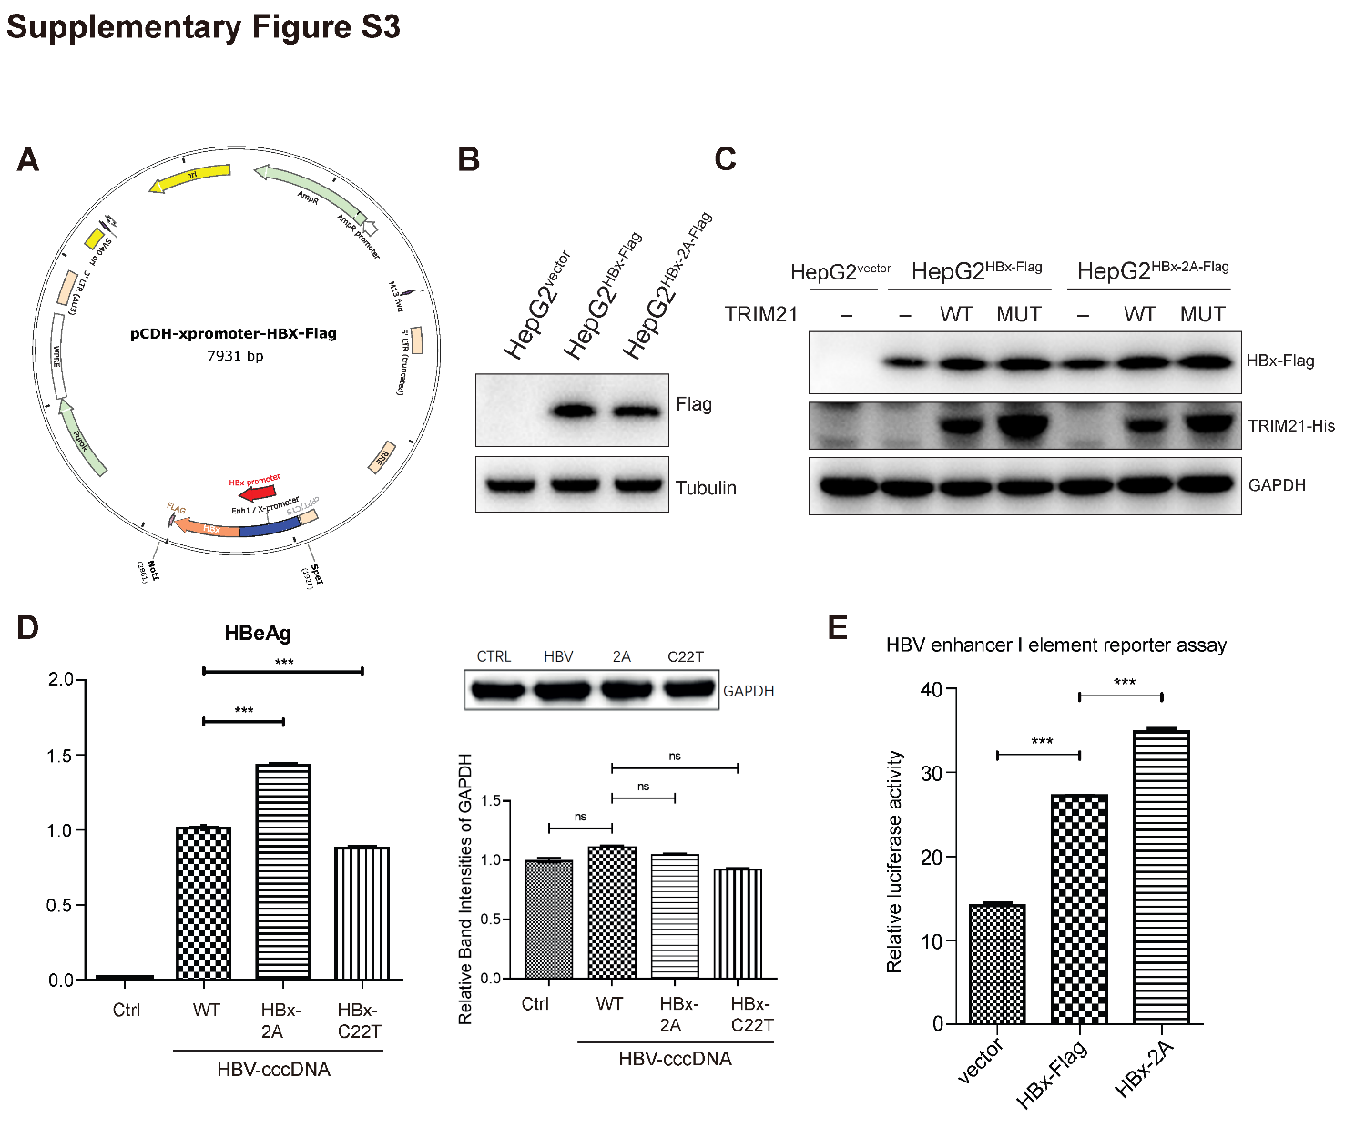
Supplementary Fig. S3. TRIM21-mediated HBx ubiquitination disrupts HBV replication. A Map of the HBx-expressing plasmid with viral enhancer I/X promoter. The enhancer I/X promoter region (951–1373) and the coding region of HBx (1374-1835) of HBV genome were amplified and inserted to the pCDH backbone between SpeI and NotI restriction sites. The original CMV promoter was deleted in the modified plasmid. B Immunoblotting analysis of HBx levels in HBx- or HBx-2A-expressing HepG2 stable cells. C TRIM21 overexpression cannot promote HBx degradation in HBx-expressing HepG2 stable cells. D T/S-to-A substitutions at T81/S104 of HBx (HBx-2A) in HBV genome increased the expression of HBeAg in the culture medium of HepG2 cells. WT or mutant HBV-cccDNA was transfected into HepG2 cells. The left panel shows the expression levels of HBeAg analyzed by ELISA, and the right panel displays GAPDH protein levels in each group estimated by Western blot. E HEK293T cells were co-transfected with a reporter plasmid carrying the HBV enhancer I element, pRL-TK, and either HBx or HBx-2A. The cells were harvested and subjected to a dual-luciferase assay. Data were represented as the mean ± s.d. from three biological replicates, ***P < 0.001. (Student’s t-test)

Captions of supplementary tables
Supplementary Table S1. The correlations between the expression levels of human E3 ligases and HBV integration.
Supplementary Table S2. The information of 50 HCC samples and 5 matched tumor-adjacent l samples from 50 Chinese patients.
Supplementary Table S3. The detailed information of HBV integration sites in human genome.
Supplementary Table S4. The gene expression profiling of E3 ligases in HCC samples.
Supplementary Table S5. Antibodies list.
Supplementary Table S6. Plasmids list.

