Virologica Sinica
Supplementary Data

Identification of fangchinoline as a broad-spectrum enterovirus inhibitor through reporter virus based high-content screening

Qiu-Yan Zhang ^{a, b, 1}, Jia-Qi Li ^{b, 1}, Qi Li ^{b}, Yang Zhang ^{c}, Zhe-Rui Zhang ^{b}, Xiao-Dan Li ^{d}, Hong-Qing Zhang ^{b}, Cheng-Lin Deng ^{b}, Feng-Xia Yang ª, Yi Xu ^{1,*}, Bo Zhang ^{a, b, *}

ª The Joint Center of Translational Precision Medicine, Department of Infections and Diseases, Guangzhou Institute of Pediatrics, Guangzhou Women and Children's Medical Center, Guangzhou, 510623, China.
^{b} Key Laboratory of Special Pathogens and Biosafety, Wuhan Institute of Virology, Center for Biosafety Mega-Science, Chinese Academy of Sciences, Wuhan, 430071, China.
^{c} University of Science and Technology of China, Department of Life Sciences and Medicine, Hefei, 230026, China.
^{d} Hunan Normal University, School of Medicine, Changsha, 410081, China.

¹ Qiu-Yan Zhang and Jia-Qi Li contributed equally to this work.

*Corresponding author:
Email addresses: zhangbo@wh.iov.cn (B. Zhang); xuyi70@163.com (Y. Xu)
ORCID: 0000-0002-8895-3679 (B. Zhang); 0000-0001-8971-9334 (Y. Xu)

Supplementary Materials and Methods
Simplified time of addition assay
To preliminarily determine which part of the viral life cycle the compound inhibits, simplified time-of-addition assay was conducted. Vero cells were seeded in 24-well plates (8×10⁴ cells per well). After one day cultivation, the cells were treated with fangchinoline (FAN) (10 μmol/L) or DMSO during the following period: full-time-infection (0 to 12 h), during-time-infection (0–2 h), and post-time-infection (2–12 h). The DMSO-treatment group of the final selected studies was consistent with that of the “full-time” group. For all the experimental groups, the cells were infected with CV-A10, CV-B3, CV-A16-24 and CV-A16-119 (MOI = 1/0.1/1/1, respectively) at 37 ℃ for 12 h. Viral titer in cell supernatant was quantified by plaque assay. Inhibition rates were calculated as “1 − the percentage of viral titer in treatment group relatively to that of DMSO control”.

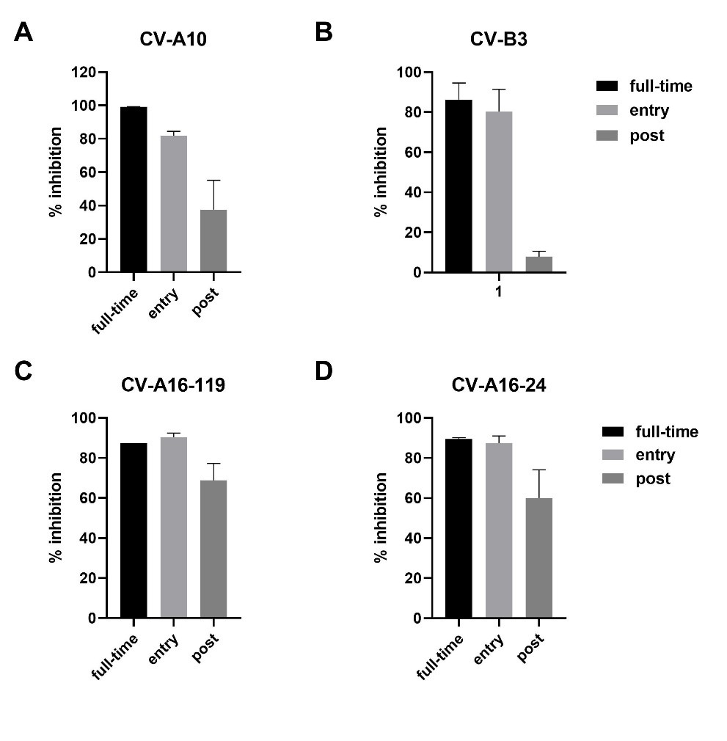
Figure S1. Analysis of simplified time of addition assay. Vero cells were infected with CV-A10 (A), CV-B3 (B), CV-A16-199 (C) and CV-A16-24 (D) at an MOI of 1/0.1/1/1 at 37 °C for 2 h, respectively. The infected cells were washed three times with PBS. FAN (10 μmol/L) was added into Vero cells full-time of-, during- or post- virus infection. The supernatants were assayed for determination of viral titers at 12 hours post-infection. The inhibition rates were calculated as “1 − the percentage of viral titer in treatment group relatively to that of DMSO control”.

Table S1. Details of primers used in the infectious clones’ construction and RT-PCR amplification.
Primer Name | Genome position | Utilities | Sequence
EV71-XbaI-1300F | 1341 | Fusion PCR/RT-PCR/Sequencing | CTAG TCTAGA GTCATTGGGACAGTAGCAGGC
EV71-HindIII-3799R | 3821 | Fusion PCR/RT-PCR/Sequencing | CTAG AAGCTT CTGCGTCAGTGAAGCCTGTT
EV71-VP1-E145G-F | __ | E145G construction | CCACCGGGGgAGTTGTCCCACAATTGCTCC
EV71-VP1-E145G-R | __ | E145G construction | TGTGGGACAACTcCCCCGGTGGGTGTGCAC
EV71-VP1-V258I-F | __ | V258I construction | ATGAAGCACaTCAGGGCGTGGATACCTC
EV71-VP1-V258I-R | __ | V258I construction | TCCACGCCCTGAtGTGCTTCATTCTCATG
EV71-T7-5NTR-F | 1 | RT-PCR/Sequencing | ACGACTCACTATTAAG CTG TGG GTT GCA CCC A
EV71-HidIII-1508-R | 1489 | RT-PCR/Sequencing | CTAG AAGCTT CCTCAAATTAATCCACTGGT
EV71-XbaI-3641F | 3641 | RT-PCR/Sequencing | CTAG TCTAGA CTCAGAACCTGGTGATTGC
EV71-HindIII-6440R | 6420 | RT-PCR/Sequencing | CTAG AAGCTT AATTTTATCAATCGAGCGCAG
EV71-XbaI-5878F | 5878 | RT-PCR/Sequencing | CTAG TCTAGA GCAATGGCAGACAAGGTTTT
EV71-HidIII-poly(T) | 3’ tail | RT-PCR/Sequencing | CTAG AAGCTT TTT TTT TTT TTT TTT TTT TTT TTT T
EV71-45-F | 45 | Sequencing | CGCAGCACTCTGGTACCTC
EV71-878-F | 878 | Sequencing | TCTCAAGCAGGATCCAGACA
EV71-1878-F | 1878 | Sequencing | AATAATGTGCCCACGAATGC
EV71-2388-F | 2388 | Sequencing | ATGAAATTGTGCAAGGATGC
EV71-2897-F | 2897 | Sequencing | TATGTTTGTGCCACCTGGAG
EV71-4911-F | 4911 | Sequencing | AAACGTTGCAGCCCATTAGT
EV71-6401-F | 6401 | Sequencing | CACTTATGTCAAGGACGAGCTG

