Virologica Sinica

Supplementary Data

Ancient dormant virus remnant ERVW-1 drives ferroptosis via degradation of GPX4 and SLC3A2 in schizophrenia

Dongyan Zhang ª, Xiulin Wu ª, Xing Xue ª, Wenshi Li ª, Ping Zhou ª, Zhao Lv ª, Kexin Zhao ª, Fan Zhu ^{a.b, *}

ª State Key Laboratory of Virology and Department of Medical Microbiology, School of Basic Medical Sciences, Wuhan University, Wuhan, 430071, China
^{b} Hubei Province Key Laboratory of Allergy & Immunology, Wuhan University, Wuhan, 430071, China

*Corresponding author.
E-mail address: fanzhu@whu.edu.cn; zhufan@hotmail.com (F. Zhu)
ORCID: 0000-0001-7031-2956 (F. Zhu)

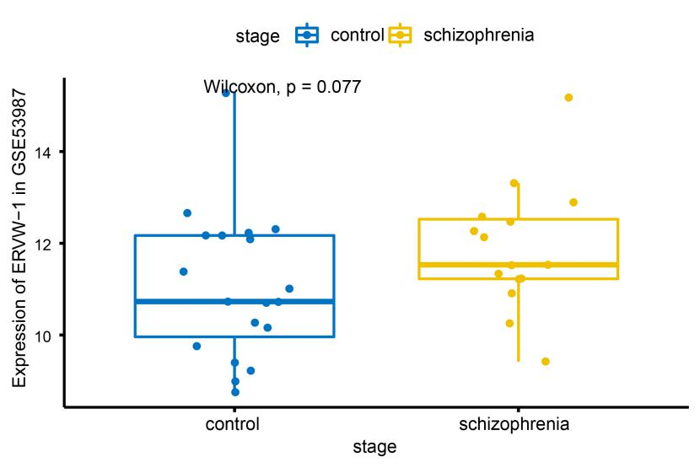
Fig. S1 The level of ERVW-1 in GSE53987.
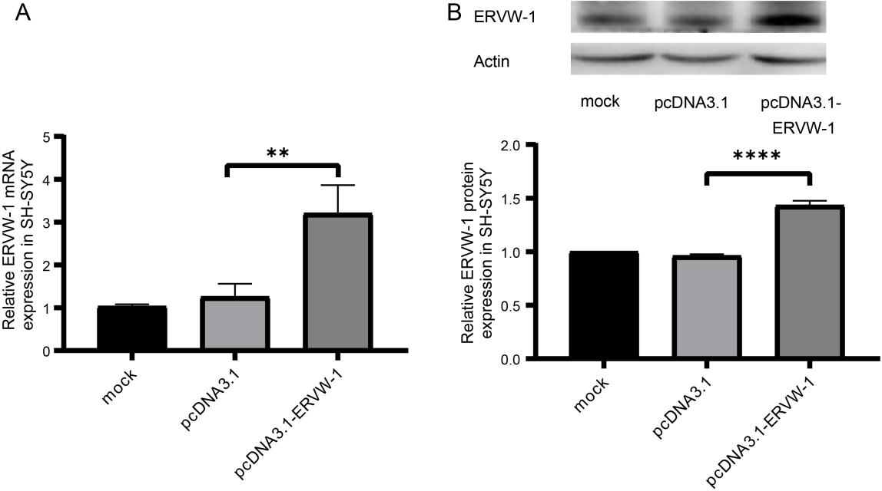
Fig. S2 The transfection efficiency of ERVW-1 in SH-SY5Y cells. A The mRNA levels of ERVW-1 in ERVW-1 overexpressing SH-SY5Y cells using quantitative polymerase chain reaction (qPCR). B Western blot detection of ERVW-1 protein levels in ERVW-1 overexpressing SH-SY5Y cells. *P < 0.05; **P < 0.01; ***P <0.001. All experiments were repeated three times. Statistical analysis: one-way ANOVA.
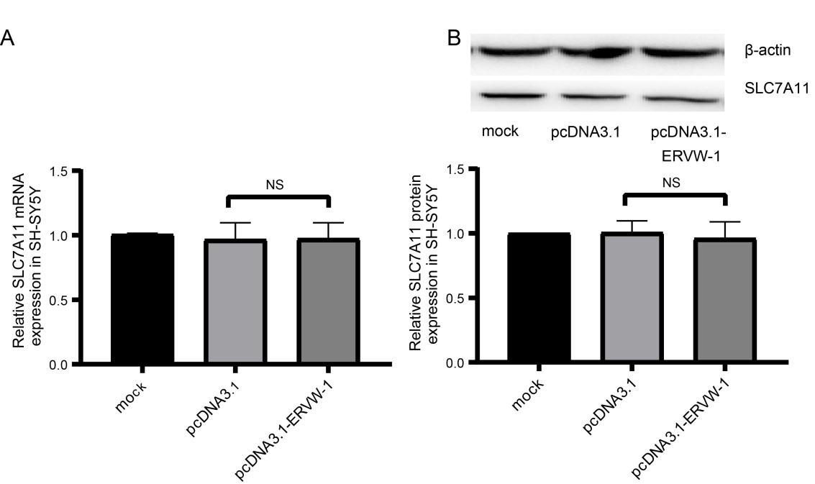
Fig. S3 ERVW-1 didn’t affect the expression of SLC7A11. A The mRNA levels of SLC7A11 in ERVW-1 overexpressing SH-SY5Y cells using quantitative polymerase chain reaction (qPCR). B Western blot detection of SLC7A11 protein levels in ERVW-1 overexpressing SH-SY5Y cells. ^{NS}P > 0.05. All experiments were repeated three times. Statistical analysis: one-way ANOVA.
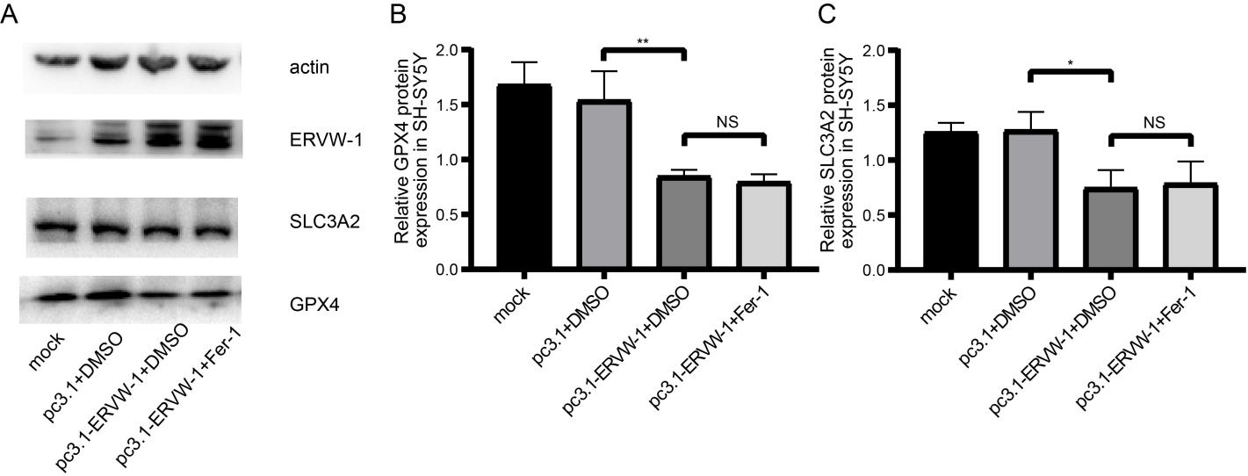
Fig. S4 Fer-1 had no significant effect on the expression of GPX4 and SLC3A2 proteins. (A, B, C) Fer-1 had no significant effect on the expression of GPX4 and SLC3A2 proteins. *P < 0.05; **P < 0.01; ^{NS}P > 0.05. All experiments were repeated three times. Statistical analysis: one-way ANOVA.

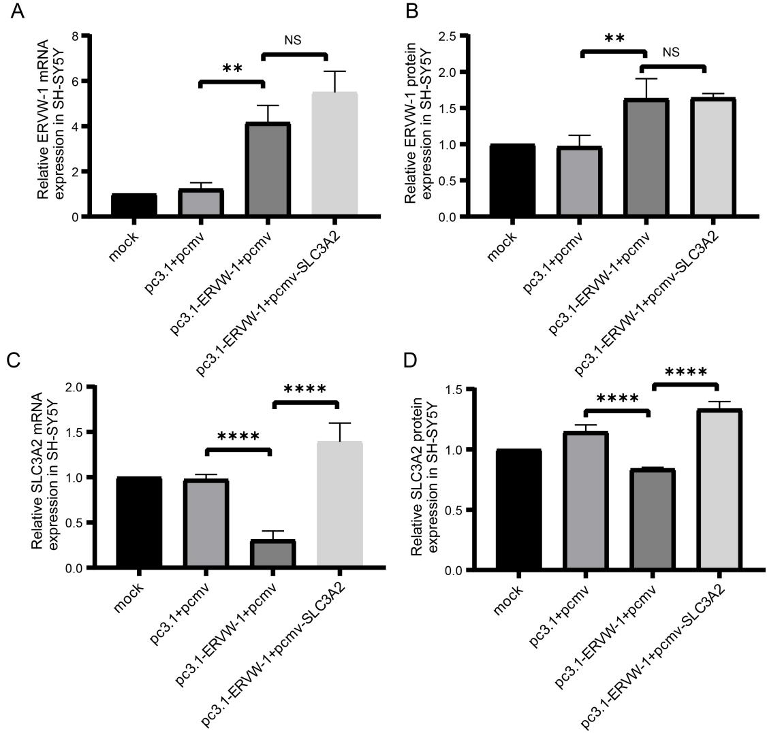
Fig. S5 Detection of related-gene expression after co-transfection of pCMV-SLC3A2 and pc3.1-ERVW-1. A ERVW-1 mRNA levels of pCMV-SLC3A2 co-transfected with pc3.1-ERVW-1 or control vector in SH-SY5Y cells. B ERVW-1 protein levels of pCMV-SLC3A2 co-transfected with pc3.1-ERVW-1 or control vector in SH-SY5Y cells. C SLC3A2 mRNA levels of pCMV-SLC3A2 co-transfected with pc3.1-ERVW-1 or control vector in SH-SY5Y cells. D SLC3A2 protein levels of pCMV-SLC3A2 co-transfected with pc3.1-ERVW-1 or control vector in SH-SY5Y cells. *P < 0.05; **P < 0.01; ***P <0.001; ^{NS}P > 0.05. All experiments were repeated three times. Statistical analysis: one-way ANOVA.
Supplementary Table S1. Primer sequence for real-time PCR and cloning used in this study
Primer name | Primer sequences | Enzyme
Primers for real-time PCR:
ERVW-1 sense: | 5'-CCAATGCATCAGGTGGGTAAC-3'
ERVW-1 antisense: | 5'-GAGGTACCACAGACAAAAAATATTCCT-3'
GPX4 sense: | 5'-TGGACAAGTACCGGGGCTT-3'
GPX4 antisense: | 5'-ACTGGTTACACGGGAAGGC-3'
SLC3A2 sense: | 5'-TGAATGAGTTAGAGCCCGAGA-3'
SLC3A2 antisense: | 5'-GTCTTCCGCCACCTTGATCTT-3'
SLC7A11 sense: | 5'-TCTCCAAAGGAGGTTACCTGC-3'
SLC7A11 antisense: | 5'-AGACTCCCCTCAGTAAAGTGAC-3'
Primers for cloning
GPX4 sense: | 5'-CGCGGATCCATGAGCCTCGGCCGC-3' | BamHI
GPX4 antisense: | 5'-CCGGAATTCGAAATAGTGGGGCAG-3' | EcoRI
SLC3A2 sense: | 5'-CGCGGATCCATGGAGCTACAGCCCTCCTGAAG-3' | BamHI
SLC3A2 antisense: | 5'-CCGGAATTCGGCCGCGTAGGGGAAGC-3' | EcoRI
Primers for SLC3A2 promoter construct:
(-588/+212) SLC3A2 sense: | 5’-CGACGCGTGCTATTTTCTGAACAGACGGCTA-3’ | MluI
(-388/+212) SLC3A2 sense: | 5’-CGACGCGTATCCGCCAGTCGCCCT-3’ | MluI
(-188/+212) SLC3A2 sense: | 5’-CGACGCGTGCCGCAGAGGCCCAC-3’ | MluI
(+12/+212) SLC3A2 sense: | 5’-CGACGCGTTGGTTTTCTCACCCAGTGCATG-3’ | MluI
Antisense: | 5’-CCGCTCGAGCGCGGAATCGACACGACG-3’ | XhoI
Primers for GPX4 promoter construct:
(-700/+100) GPX4 sense: | 5’-GGGTACCAAAAAAACTGTGTCTCGGA-3’ | KpnI
(-500/+100) GPX4 sense: | 5’-GGGTACCTGTTGTCCCAGCTACTCGG-3’ | KpnI
(-300/+100) GPX4 sense: | 5’-GGGTACTTAAGTAGTATTCTCAGGTTG-3’ | KpnI
(-100/+100) GPX4 sense: | 5’-GGGTACCTGACGTCGGCGCGAGCGCTCA-3’ | KpnI
Antisense: | 5’-CCTCGAGCCACAGAGCAGCGCCGGCTTC-3’ | XhoI

